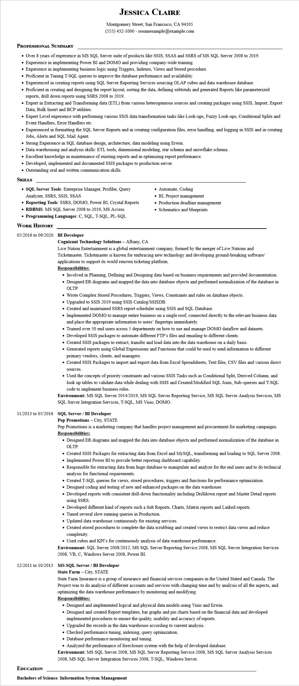
JESSICA CLAIRE
Montgomery Street, San Francisco, CA 94105
(555) 432-1000 - resumesample@example.com
PROFESSIONAL SUMMARY
• Over 8 years of experience in MS SQL Server suite of products like SSIS, SSAS and SSRS of MS SQL Server 2008 to 2019.
• Experience in implementing Power BI and DOMO and providing company-wide training.
• Experience in implementing business logic using Triggers, Indexes, Views and Stored procedure.
• Proficient in Tuning T-SQL queries to improve the database performance and availability.
• Experienced in creating reports using SQL Server Reporting Services sourcing OLAP cubes and data warehouse database.
• Proficient in creating and designing the report layout, sorting the data, defining subtotals and generated Reports like parameterized reports, drill down reports using SSRS 2008 to 2019.
• Expert in Extracting and Transforming data (ETL) from various heterogeneous sources and creating packages using SSIS, Import, Export Data, Bulk Insert and BCP utilities
• Expert Level experience with performing various SSIS data transformation tasks like Look-ups, Fuzzy Look-ups, Conditional Splits and Event Handlers, Error Handlers etc.
• Experienced in formatting the SQL Server Reports and in creating configuration files, error handling, and logging in SSIS and in creating Jobs, Alerts and SQL Mail Agent.
• Strong Experience in SQL database design, architecture, data modeling using Erwin.
• Data warehousing and analysis skills: ETL tools, dimensional modeling, star schema and snowflake schema.
• Excellent knowledge in maintenance of existing reports and in optimizing report performance.
• Developed, implemented and documented SSIS packages to production server.
• Outstanding oral and written communication skills.
SKILLS
• SQL Server Tools: Enterprise Manager, Profiler, Query Analyzer, SSRS, SSIS, SSAS
• Reporting Tools: SSRS, DOMO, Power BI, Crystal Reports
• RDBMS: MS SQL Server 2008 to 2019, MS Access
• Programming Languages: C, SQL, T-SQL, PL-SQL WORK HISTORY
05/2016 to 09/2020 BI Developer
Cognizant Technology Solutions - Albany, CA
• Automate, Coding
• BI, Project management
• Production deadline management
• Schematics and blueprints
Live Nation Entertainment is a global entertainment company, formed by the merger of Live Nations and Ticketmaster. Ticketmaster is known for embracing new technology and developing ground-breaking software/ applications to support its world renown ticketing platform.
Responsibilities:
• Involved in Planning, Defining and Designing data based on business requirements and provided documentation. • Designed ER diagrams and mapped the data into database objects and performed normalization of the database in OLTP.
• Wrote Complex Stored Procedures, Triggers, Views, Constraints and rules on database objects.
• Upgraded to SSIS 2019 using SSIS Catalog/SSISDB.
• Created and maintained SSRS report scheduler using SSIS and SQL Database.
•
Implemented DOMO to manage entire business on a single roof, connected directly to the relevant business data and place the appropriate information to users' fingertips immediately.
• Trained over 50 end users across 5 departments on how to use and manage DOMO dataflow and datasets.
• Developed SSIS packages to automate different FTP's files and emailing to different clients.
• Created SSIS packages to extract, transfer and load data into the data warehouse on a daily basis.
• Generated reports using Global Expressions and Functions that could be used to send information to different primary vendors, clients, and managers.
• Created SSIS Packages to import and export data from Excel Spreadsheets, Text files, CSV files and various direct
sources.
• Used the concepts of priority constraints and various SSIS Tasks such as Conditional Split, Derived Column, and look up tables to validate data while dealing with SSIS and Created/Modified SQL Joins, Sub-queries and T-SQL code to implement business rules.
Environment: MS SQL Server 2014/2019, MS SQL Server Reporting Service, MS SQL Server Analysis Services, MS SQL Server Integration Services, T-SQL, MS Visio, DOMO.
11/2013 to 05/2016 SQL Server / BI Developer
Pep Promotions - City, STATE
Pep Promotions is a marketing company that handles project management and procurement for marketing campaigns. Responsibilities:
• Designed ER diagrams and mapped the data into database objects and performed normalization of the database in OLTP.
• Created SSIS Packages for extracting data from Excel and MySQL, transforming and loading to SQL Server 2008. • Implemented Power BI to provide better reporting dashboard capability.
• Responsible for extracting data from huge database to manipulate and analyze for the end users and to do technical analysis for functional requirements.
• Created T-SQL queries for views, stored procedures, triggers and functions for performance optimization.
• Designed coding and testing of new and enhanced packages on the data warehouse.
• Developed reports with consistent drill-down functionality including Drilldown report and Master Detail reports using SSRS.
• Developed different kind of reports such a Sub Reports, Charts, Matrix reports and Linked reports.
• Tuned several slow running queries in Production.
• Updated data warehouse continuously for existing services.
• Created stored procedures to complete the data scrubbing and created views to restrict data views and reduce complexity.
• Used cubes and KPI's for continuously analysis of data warehouse performance.
Environment: SQL Server 2008/2012, MS SQL Server Reporting Service 2008, MS SQL Server Integration Services 2008, VB, C, Windows Server 2008, Power BI.
12/2011 to 10/2013 MS SQL Server / BI Developer
State Farm - City, STATE
State Farm Insurance is a group of insurance and financial services companies in the United Stated and Canada. The Project was to do analysis of different accounts and services with changing time and by analysis of all the aspects, and optimizing the data warehouse performance by monitoring and modifying.
Responsibilities:
• Designed and implemented logical and physical data models using Visio and Erwin.
• Designed and created Report templates, bar graphs and pie charts based on the financial data and developed implemented procedures to ensure the quality, usability and accuracy of reports.
• Upgraded the records in the data warehouse according to current analysis.
• Checked performance tuning, indexing, query optimization.
• Database performance monitoring and tuning.
• Analyzed the performance of foreclosure system with the help of developed database.
Environment: MS SQL Server 2008, MS SQL Server Reporting Service 2008, MS SQL Server Analysis Services
2008, MS SQL Server Integration Services 2008, T-SQL, Windows Server.
EDUCATION
Bachelors of Science: Information System Management

